**Advanced Charts**

1. Combo Chart

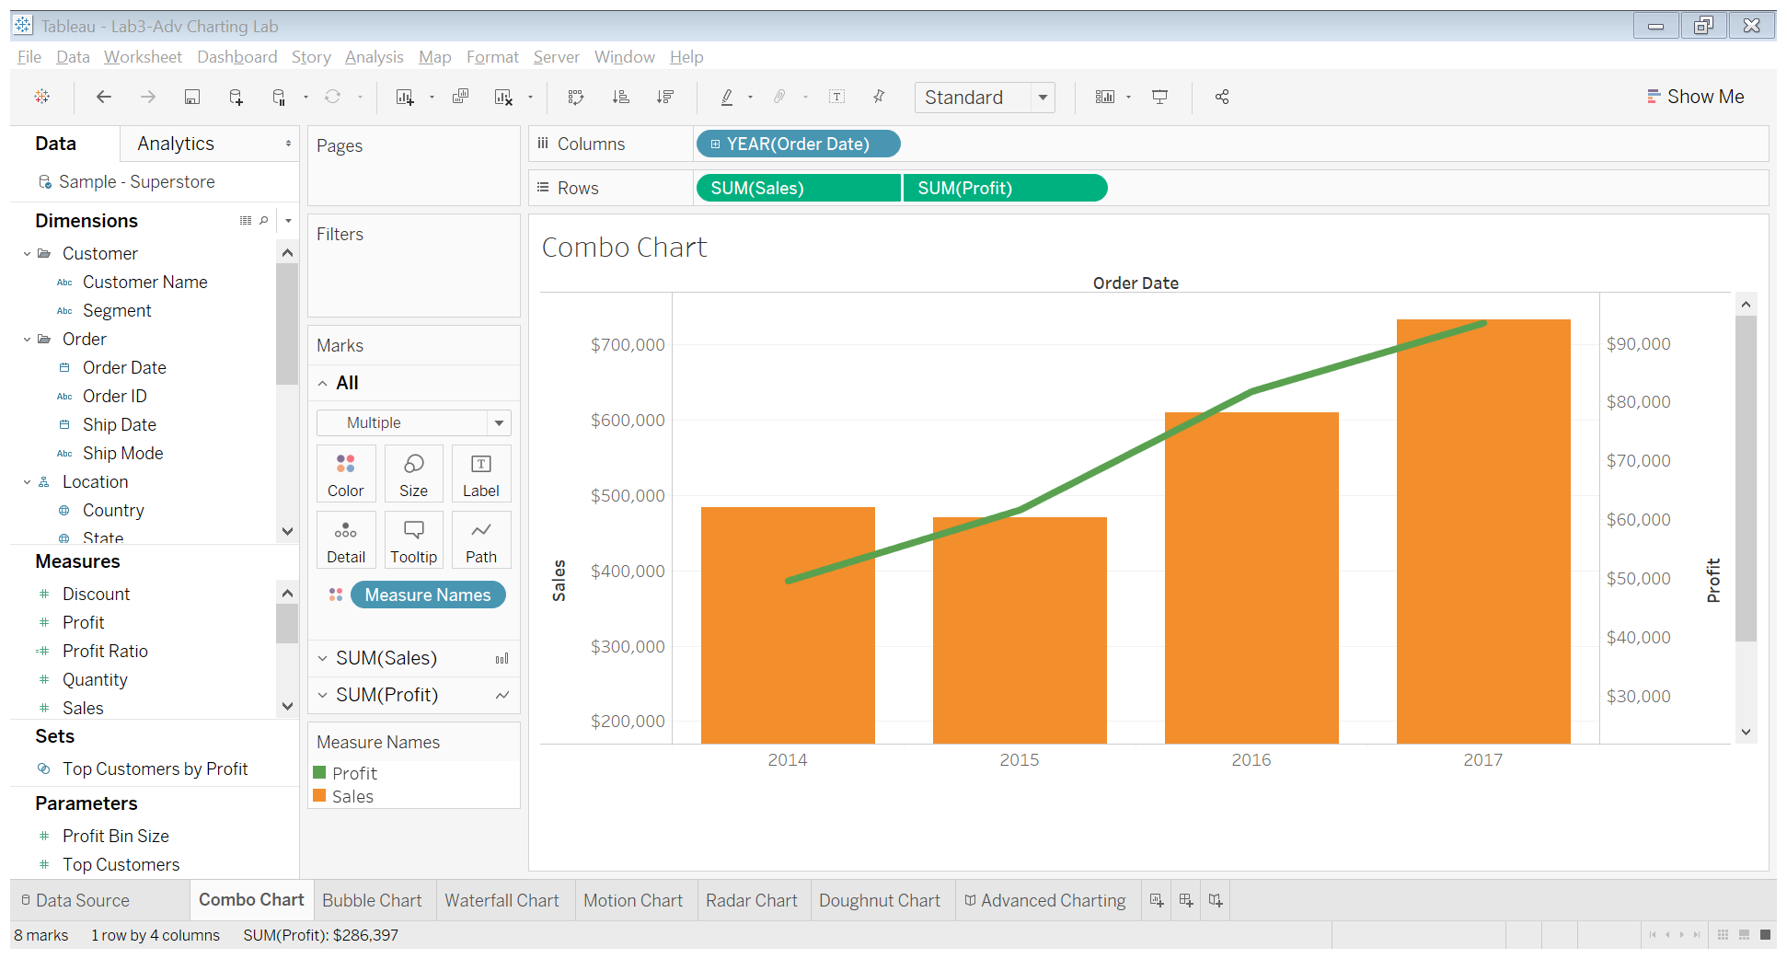

Dual-axis combination charts, or Combo Charts, are an effective chart type for showing related information while saving real estate by combining views. This chart type is created with one shared axis, such as an X-axis for date, and two separate axes, such as Y-axes for two different measures.

**Tableau Public link**: <https://public.tableau.com/profile/vibha.desai#!/vizhome/TableauLab3-AdvChartingLab/ComboChart?publish=yes>

1. Bubble Chart

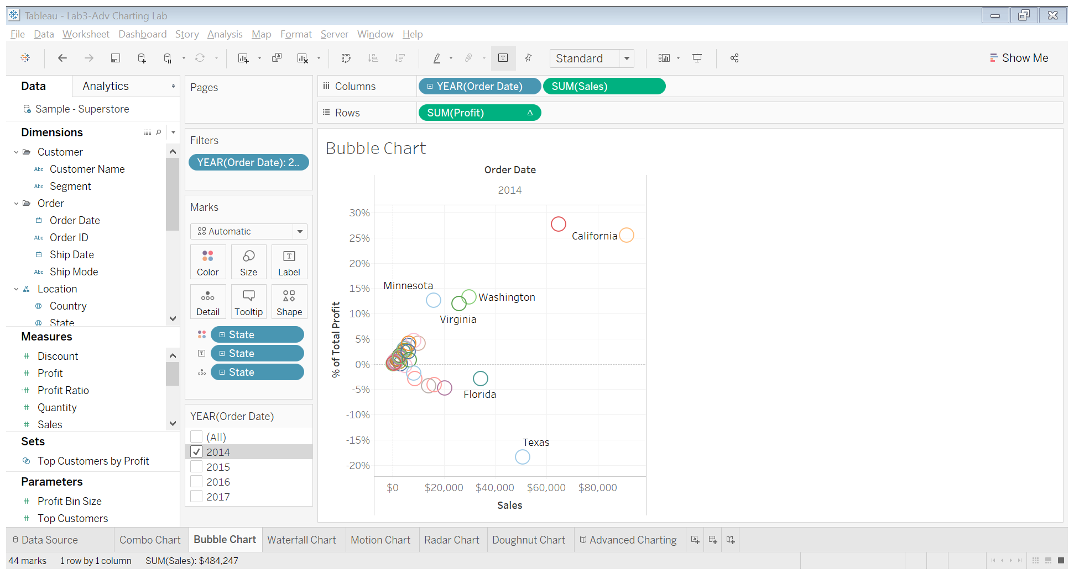

Bubble charts display data as a cluster of circles. Each of the values in the dimension field represents a circle whereas the values of measure represent the size of those circles. As the values are not going to be presented in any row or column, you can drag the required fields to different shelves under the marks card.

**Tableau Public link**: <https://public.tableau.com/profile/vibha.desai#!/vizhome/TableauLab3-AdvChartingLab/BubbleChart>

1. Waterfall Chart

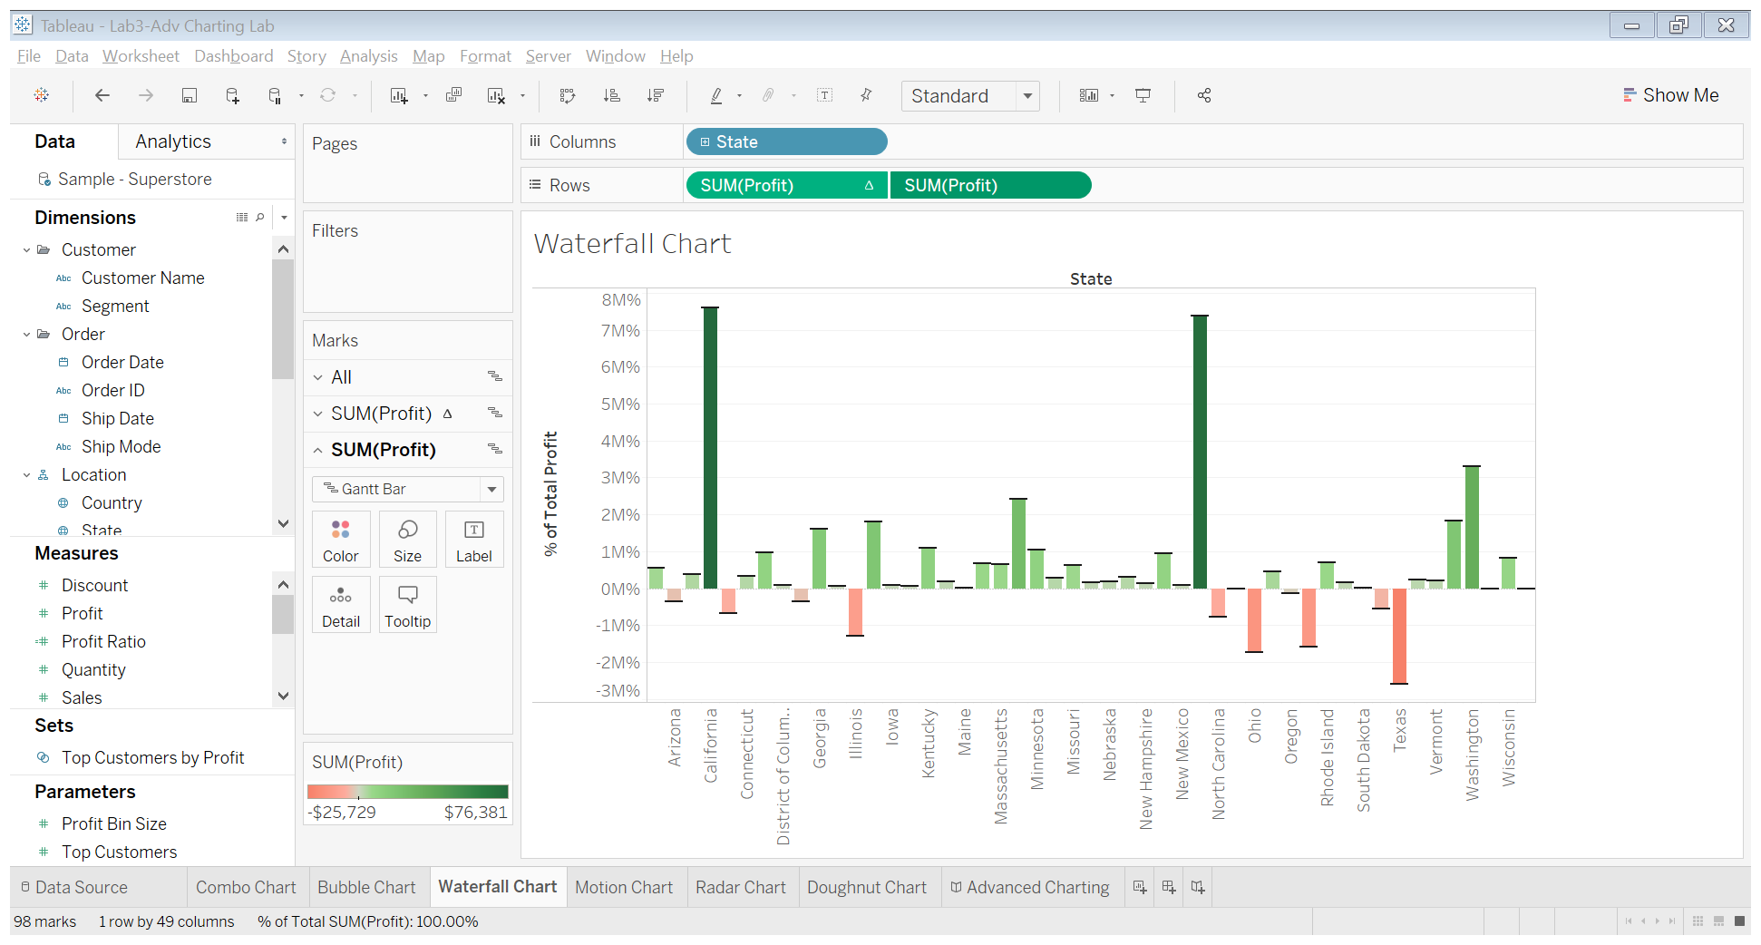

Waterfall charts effectively display the cumulative effect of sequential positive and negative values. It shows where a value starts, ends and how it gets there incrementally. So, we are able to see both the size of changes and difference in values between consecutive data points. Tableau needs one Dimension and one Measure to create a Waterfall chart.

**Tableau Public link**: <https://public.tableau.com/profile/vibha.desai#!/vizhome/TableauLab3-AdvChartingLab/WaterfallChart>

1. Motion Chart

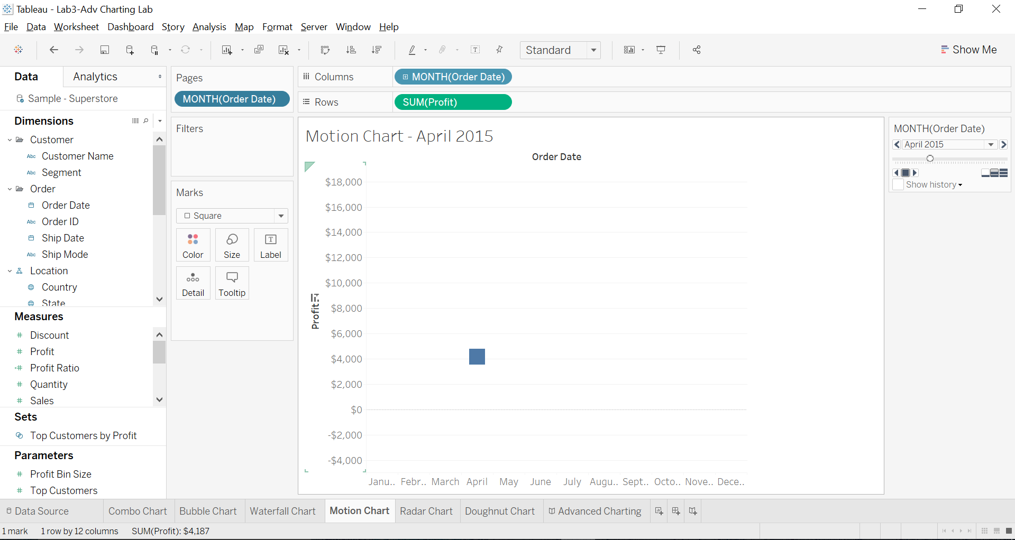

Motion charts show data using the X and Y-axes, displaying changes over time by showing the movement of data points within the defined space as well as changes in the color of the lines. The main advantage of motion chart is to view the entire trail of how the data has changed over time and not just a snapshot of the data. Tableau needs one Time Dimension and one Measure to create a Motion chart.

**Tableau Public link**: <https://public.tableau.com/profile/vibha.desai#!/vizhome/TableauLab3-AdvChartingLab/MotionChart>

1. Radar Chart

Radar charts are a great way to compare members of a dimension in a function of several metrics. For example, when you want to buy a smartphone, you can use a radar chart to compare several devices across several metrics like battery life, camera quality, and memory capacity.

|  |  |  |
| --- | --- | --- |
| ID | Event | Medals Won |
| 1 | Snowboarding | 25 |
| 2 | Free-style Gymnastics | 20 |
| 3 | Diving | 20 |
| 4 | Alpine skiing | 25 |
| 5 | Cycling | 20 |
| 6 | Relay Race | 20 |
| 7 | Snowboarding | 25 |

Data Used:

|  |  |  |
| --- | --- | --- |
| ID | Event | Medals Won |
| 1 | Snowboarding | 25 |
| 2 | Free-style Gymnastics | 20 |
| 3 | Diving | 20 |
| 4 | Alpine skiing | 25 |
| 5 | Cycling | 20 |
| 6 | Relay Race | 20 |
| 7 | Snowboarding | 25 |

Calculation for X: case [ID1]

when 1 then [Medals Won] * 1

when 2 then [Medals Won] *(1/2)

when 3 then [Medals Won] *(-1/2)

when 4 then [Medals Won] *(-1)

when 5 then [Medals Won] * (-1/2)

when 6 then [Medals Won] *(1/2)

when 7 then [Medals Won] * 1

end

Calculation for Y: case [ID1]

when 1 then [Medals Won] *0

when 2 then [Medals Won] *(sqrt (3))/2

when 3 then [Medals Won] *(sqrt (3))/2

when 4 then [Medals Won] *0

when 5 then [Medals Won] * -((sqrt (3))/2)

when 6 then [Medals Won] * -((sqrt (3))/2)

when 7 then [Medals Won] *0

end

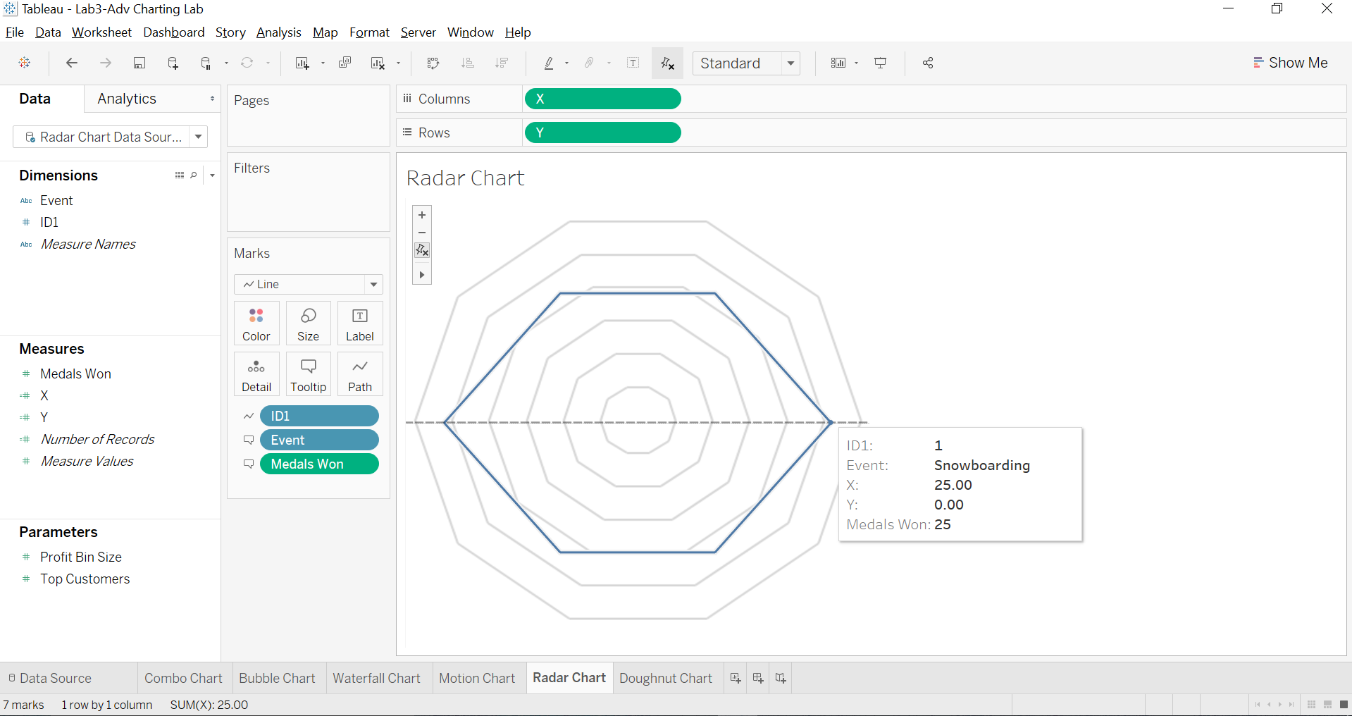

**Tableau Public link**: <https://public.tableau.com/profile/vibha.desai#!/vizhome/TableauLab3-RadarChart/RadarChart?publish=yes>

1. Single Measure/Doughnut Chart

Donut chart is a pie chart with a hole in the middle. And you can use that hole to put a nice label that usually comes up ugly in the pie chart.

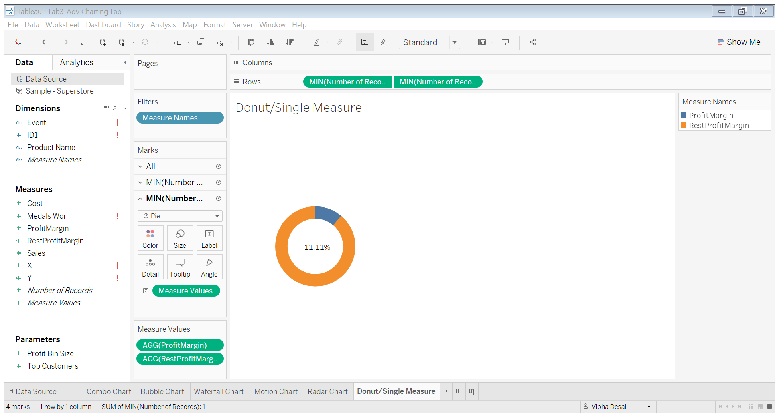

**Tableau Public link**: <https://public.tableau.com/profile/vibha.desai#!/vizhome/TableauLab3-DonutSingleMeasureChart/DonutSingleMeasure?publish=yes>